**software engineering and project management**

Assignment-1

Date: 20-02-21

Name: RAJUL DUBEY

SAP ID: 500069424

ROLLno.: R171218081

**Ans.1)** The spiral model is called a meta model since it comes within all other life cyclemodels.

Risk handling is always built into this model.

The spiral model is suitable for development of technically challenging software products that are cautious to several kinds of risks.

This model is much more complex than the other models

**Ans.2)** Advantages of using Prototype Model :

* + This model is flexible in design.
  + It is easy to detect errors.
  + We can find missing functionality easily.
  + There is scope of refinement, it means new
  + requirements can be easily accommodated.
  + Prototyping early and often is the #1 thing you can do to lower project costs.

At first this might seem unintuitive since you are spending money on prototypes.

However in the end you will be financially better off.

This is because it is much more affordable to discover and fix an issue early on than once you are gearing up for manufacturing.

Prototypes are the only way you will be able to discover a large class of issues.

**Ans.3)**

A software requirements specification (SRS) is a document that captures complete description about how the system is expected to perform.

It is usually signed off at the end of requirements engineering phase.

The important issues that a SRS must address are:

(a) System goals and requirements are different

(b) Request Definition

(c) Request Specification

(d) Software Specification

(e) Feasibility Study

(f) Suggestions for preparing an SRS Document:

**Ans.4)**

RAD should be used when there is a need to create a system that can be modularized in 2-3 months of time.

It should be used if there's high availability of designers for modeling and the budget is high enough to afford their cost along with the cost of automated code generating tools.

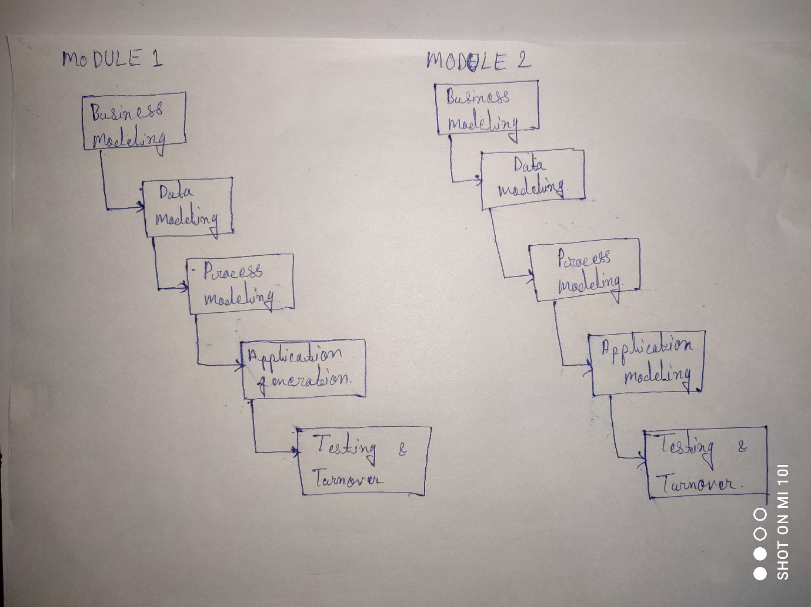

Ans5.)

